**A Simple User Guide for LBB** (for LBB_13.R)

R. Froese, H. Winker, G. Coro, N. Demirel, Athanassios C. Tsikliras, Donna Dimarchopoulou, Giuseppe Scarcella, Wolfgang Nikolaus Probst, Manuel Dureuil, Daniel Pauly

published online at <http://oceanrep.geomar.de/43182/> in June2018

This is an accompanying document for “Froese, R., Winker, H., Coro, G., Demirel, N., Tsikliras, A., Dimarchopoulou, D., Scarcella, G., Probst, W.N., Dureuil, M., Pauly, D. (2018). Estimating stock status from length frequency data. *ICES Journal of Marine Science* DOI = 10.1093/icesjms/fsy078”. The length-based Bayesian biomass estimator (LBB) is a new method for the analysis of length frequency data from the commercial fishery. LBB works for species that growth throughout their lives, such as most commercial fish and invertebrates, and requires no input in addition to length frequency data. It estimates asymptotic length (Linf), length at first capture (Lc), relative natural mortality (M/K) and relative fishing mortality (F/M) as means over the age range represented in the length-frequency sample. With these parameters as input, standard fisheries equations can be used to estimate depletion or current exploited biomass relative to unexploited biomass (B/B0). In addition, these parameters allow the estimation of the length at first capture that would maximize catch and biomass for the given fishing effort (Lc_opt), and estimation of a proxy for the relative biomass capable of producing maximum sustainable yields (Bmsy/B0). Relative biomass estimates of LBB were not significantly different from the “true” values in simulated data and similar to independent estimates from full stock assessments. This document provides a simple step-by-step guide for researchers who want to apply LBB to their own data.

The LBB version referred to in this guide is the one used in Froese et al. (2018) with minor edits.

The required R-code (LBB_13.R) and some example input files (ComDat_1.csv and Stock_ID_3.csv) can be downloaded from <http://oceanrep.geomar.de/43182/>

# Installation instructions

1) Install a recent version of R on your computer. CMSY was tested under R version 3.4.4 and 3.5.0, available from <http://www.r-project.org/>, but newer versions should also work.

2) We suggest using RStudio as an R development environment. RStudio is a free software that is available for several Operating Systems (Windows, OS, Linux, ...) and can be downloaded at <http://www.rstudio.com/products/rstudio/download/> .

3) Install the Gibbs sampler JAGS for your Operating System from the following web site: <http://sourceforge.net/projects/mcmc-jags/files/JAGS/4.x/> .

*If you are using an Operating System different from MS Windows, please comment (#) all the lines in the code containing the windows(..) function.*

4) In order to run the code, several R-packages are required. In the R Console execute the following commands (i.e. cut & paste into the Console window, then hit Enter and wait):

install.packages("R2jags")

install.packages("Hmisc")

install.packages("lattice")

install.packages ("survival")

install.packages ("Formula")

install.packages ("ggplot2")

(pay attention to possible required sub-packages, as alerted in warning/error messages form the R installer, and install missing packages if needed).

5) Two different data files are required by LBB, which should be placed in the same directory as the script. The names of these files are specified in the code (line 20 for Stock ID info) and as first parameter in each line of the Stock ID file. Examples are provided with the code and their structure is specified in the next section.

6) Make sure that the source file and the downloaded R script are in the same directory.

7) Open the downloaded LBB script (LBB_11.R) in RStudio. Use the tab “Session” and select “Set Working Directory” -> “To Source File Location”, so that the code will find the data files. Alternatively, in line 17 of the code, you can explicitly state your working directory.

8) If you want to use your own input files, just change the file name of the ID.File in line 20 and the name in the File column of the ID file for the respective stock. If you create your own input files, make sure you use the same headers (case sensitive) as in the provided example files. Make sure you are using comma-delimited (.csv) files (look at the data in a simple text editor such as Notepad to check for consistent use of commas; semi-colons are not accepted).

9) The R-code can either analyze all stocks in the data files or a single stock can be specified in the “Select stock to be analyzed” section of the code, according to the stock identification specified at line 14. To specify the stock to analyze just enter the unique name or identifier of the stock there (e.g. Stock <- “tur.27.4”). To make the code run on all the stocks in the ID-file, just comment out line 14 (put # in front).

10) In RStudio, click on “Source” (or press Ctrl+A followed by Ctrl+R or Ctrl + Shift + S) to execute the code.

11) When the analysis is complete, results can be found in the console window as well as in the LBB graphs window (which can be saved manually).

# Structure of the input files

**Structure of the data file (.csv)**

For each stock, the following information must be specified (in the corresponding columns):

**Stock**: a unique fish stock name or identifier (e.g. “cod-2532”), repeated for each year

**Year**: the reporting year of the length data (e.g. 2004). One row for each year.

**CatchNo**: catch value, in number of individuals (e.g. 12345). One row for each year.

**Structure of ID file (.csv)**

For each stock, the following information must be specified (in the corresponding columns):

**File:** The name of data file in csv format

**Stock**: a unique stock name or identifier (corresponding to the one in the ‘Stock’ column in the data file)

The following information is optional (default NA or FALSE)

**Species:** the scientific name of the species, e.g. “Phycis blennoides”

**StartYear**: the first year with LF data to be used, e.g. 2000

**EndOfYear**: the last year with LF data to be used, e.g. 2004

**Years.user**: a string of years to be analyzed, e.g. “2000, 2002, 2004”

**Gears.user**: Gears to be analyzed, e.g. “trawl1, LL2, trap3”

**Lcut.user:** lower threshold for length data. Data will be restricted to those L >= Lcut.user:

**Lc.user:** user-specified prior for length at 50% first capture, e.g. 27

**Lstart.user**: length where gear retention is larger than 95%, e.g. 85

**Linf.user**: Linfinity or asymptotic length of the von Bertalanffy growth function, e.g. 110

**MK.user:** user-specified M/K prior, e.g. 2.0

**mm.user:** a Boolean value to specify if length is expressed in millimeters; default is FALSE

**GausSel:** a Boolean value to specify if gill net selection is used; default is FALSE

**MergeLF**: a Boolean value to aggregate LFs with previous year (except for first year); default is FALSE

**Lm50**: length at which 50 percent reach maturity, e.g. 28

**Comment**: a comment on the stock or the quality of the analysis or special settings. This comment is shown in the output.

Remember that the files must be saved in “csv” (comma delimited) format. Double-check that indeed a comma (and not a semi-colon) is used as delimiter.

# Results of LBB analysis

The screen output for turbot (*Scophthalmus maximus*) in the North Sea (tur.27.4) is shown on the next two pages.

Running Jags model to fit SL and N distributions for *Scophthalmus maximus* in 2010 2011 2012 2013 2014 ....

----------------------------------------------------------------------

Results for *Scophthalmus maximus* , stock tur.27.4 , 2010 - 2014

(95% confidence limits in parentheses) File: ComDat_1.csv

-----------------------------------------------------------------------

Linf prior = 81.5 , SD = 0.815 (cm)

Z/K prior = 5.25 , SD = 3.37 , M/K prior = 1.5 , SD = 0.15

F/K prior = 3.75 (wide range with tau=4 in log-normal distribution)

Lc prior = 26.5 , SD = 2.65 (cm) , alpha prior= 52.9 , SD = 5.29

General reference points [median across years]:

Linf = 82.4 (81-83.9) cm

Lopt = 55 cm, Lopt/Linf = 0.67

Lc_opt = 48 cm, Lc_opt/Linf = 0.58

M/K = 1.51 (1.17-1.84)

F/K = 2.63 (2.23-2.92)

Z/K = 4.09 (3.92-4.31)

F/M = 1.74 (1.25-2.52)

B/B0 F=M Lc=Lc_opt = 0.366

B/B0 = 0.147 (0.0896-0.223)

Y/R' F=M Lc=Lc_opt = 0.0456

Y/R' = 0.0223 (0.0136-0.0338) (linearly reduced if B/B0 < 0.25)

Estimates for last year 2014 :

Lc = 24.5 (24.3-24.7) cm, Lc/Linf = 0.3 (0.296-0.301)

alpha = 54.1 ( 51.5 - 56.5 )

Lmean/Lopt = 0.64 , Lc/Lc_opt = 0.51 , L95th = 59 cm , L95th/Linf = 0.72 , Lm50 = 28 cm , Mature = 79 %

F/K = 1.2 ( 0.925 - 1.52 )

F/M = 0.84 ( 0.559 - 1.4 )

Z/K = 2.64 ( 2.46 - 2.79 )

Y/R' = 0.042 ( 0.0225 - 0.0732 ) (linearly reduced if B/B0 < 0.25)

B/B0 = 0.32 ( 0.168 - 0.546 )

B/Bmsy = 0.86 ( 0.458 - 1.49 )

Comment: Gear=TBB_DEF_70-99_0_0; ICES(3) 2014 F/Fmsy=0.63 (0.48-0.84), SSB/Bmsy=1.18 (0.87-1.61). Lm50 from Froese & Sampang 2013.

**Graphical output**

LBB produces plots of the raw data per year. This is meant to help identify and exclude years that appear unfit for analysis. The years fit for analysis can then be specified in the ID file using StartYear and EndOfYear, or by specifying a string of years in Years.user (see above).

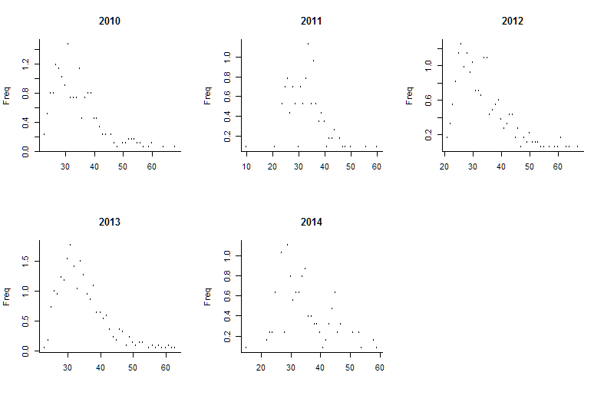

Figure 1. Length frequency data as provided to LBB. Exclude years that do not show the expected pattern.

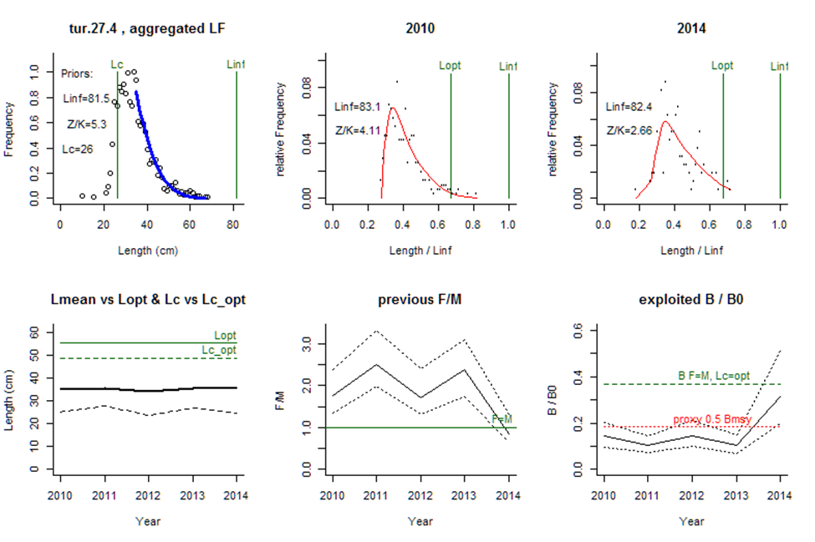

*Figure 2. An example of graphical output produced by LBB, here for North Sea turbot, for the years 2010 to 2014. The upper left panel shows the accumulated LF data used to estimate priors for Lc , Linf and Z/K. The upper middle and right panels show the LF data for the first and last year in the time series. The red curve shows the fit of Equation 8, which provides estimates Z/K, M/K, F/K, Lc , and Linf . From Linf and M/K, Lopt is calculated and shown as reference. The lower left panel shows Lmean (bold black curve) relative to Lopt , and Lc (dashed black curve) relative to Lc_opt . The lower middle panel shows relative fishing pressure F/M (black curve), with approximate 95% confidence limits (dotted curves), with indication of the reference level where F = M (green horizontal line). The lower right panel shows relative biomass B/B0 (black curve) with approximate 95% confidence limits (dotted black curves), with indication of a proxy for Bmsy (green dashed line) and a proxy for Bpa or 0.5 Bmsy (red dotted line).*

If you have any questions, contact us:

Rainer Froese [rfroese@geomar.de](mailto:rfroese@geomar.de)

Gianpaolo Coro [gianpaolo.coro@isti.cnr.it](mailto:gianpaolo.coro@isti.cnr.it)

Henning Winker [henning.winker@gmail.com](mailto:henning.winker@gmail.com)

Nazlı DEMİREL [nazdemirel@gmail.com](mailto:nazdemirel@gmail.com)

Advanced users can include LBB as a function in their own R-code. This is available in the TropFishR package available from <https://cran.r-project.org/package=TropFishR>.

Enjoy using LBB.